Email templates for Employee Campaign Coordinators
Sample Pre-Campaign Email:
Subject: United Way Community Campaign
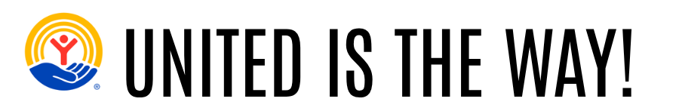
Hi [FIRST NAME],
Next week we’re kicking off [COMPANY NAME]’s United Way Community Campaign on [DATE]! This is our chance to come together and make a real difference, right here in Franklin County.
When you give to United Way, you’re helping local families access food, housing, childcare, and resources to build a stronger future. It’s about neighbors helping neighbors.
Donate for a chance to WIN! Anyone who donates $182 or more (that’s just $3.50 a week) will be entered into United Way of Franklin County’s Community Campaign Raffle! Three lucky winners will receive either a $2,000, $1,000 cash, or $500 cash.
Mark your calendar for [DATE] and keep an eye out for more information on how to participate in this year’s campaign.
Sincerely,
[CAMPAIGN COORDINATOR NAME]

Sample Campaign Kickoff Email:
Subject: United Way Campaign starts today!
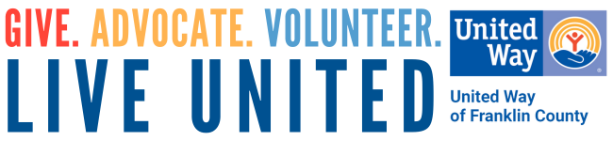
Hi [FIRST NAME],
Today is the official start [COMPANY NAME]’s United Way Campaign! Over the next [X weeks/days], you’ll have the chance to join in and support programs that are changing lives right here in Franklin County.
Your gift helps:
- Families put healthy food on the table
- People find safe, stable housing
- Kids get a strong start in school and in life
- Neighbors connect to resources like 211 when times get tough
- More people access mental health care and job training
This year, our company’s campaign goal is [INSERT GOAL]. Every gift—big or small—moves us closer.
NEW THIS YEAR! Anyone who donates $182 or more (that’s just $3.50 a week) to United Way of Franklin County will be entered into the Community Campaign Raffle! Three lucky winners will receive either a $3,500 travel voucher, $1,000 cash, or $500 cash. Please click here for more details about the raffle.
Make your pledge today [INSERT HOW TO GIVE & DEADLINE].
Thank you for your commitment to making our community a better place for all of us to live and work!
Sincerely,
[CAMPAIGN COORDINATOR NAME]

Sample Reminder Email:
Subject: Your gift can make an impact – United Way Campaign
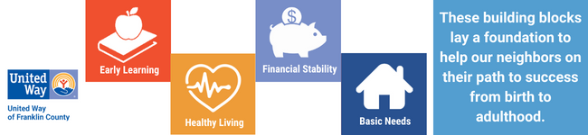
Dear [FIRST NAME],
In the midst of the United Way of Franklin County Community Campaign, I want to share some additional information about United Way and what happens after you make a pledge. Click here to review the Where Your Dollars Go Flyer. The flyer includes the programs in the community that receive grants from United Way’s Community Impact Fund. It also demonstrates how all the programs come together to make a collective impact in the lives of our community members.
To learn more about their efforts, you can visit https://www.uwfcpa.org/our-impact.
If you’ve already made your gift—thank you! If not, here’s a little extra incentive: when you donate $182 or more to United Way of Franklin County, you’ll be entered into United Way’s raffle for a chance to win a $3,500 travel voucher, $1,000 cash, or $500 cash.
We hope that you will strongly consider making a gift to the campaign. You can make a gift by [INSERT INSTRUCTIONS ON HOW TO GIVE & INCLUDE DEADLINES].
If you have any questions, please let me know and I can get an answer for you.
Sincerely,
[CAMPAIGN COORDINATOR NAME]

Sample Reminder Email:
Subject: Support families in our community that need it the most
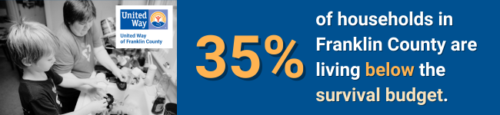
Dear [FIRST NAME],
35% of households in Franklin County are living below the ALICE (Asset Limited, Income Constrained, Employed) survival budget? The ALICE survival budget calculates the bare minimum cost of the household basics needed to live and work in the modern economy. This means that around 1/3 of families in our community struggle to afford the basics like housing, food, childcare, and transportation.
We have reached the mid-point of our United Way Campaign. By donating to United Way, you can make a difference in the lives of working families in our community that need it the most.
Currently, we [have reached XX% of our $XX goal or are X participants short of meeting our participation goal of XX%]! If you have given already, THANK YOU! If you haven’t made a gift yet, please consider getting involved.
You can make a gift by [INSERT INSTRUCTIONS ON HOW TO GIVE & INCLUDE DEADLINES].
Thank you for your consideration,
[CAMPAIGN COORDINATOR NAME]

Sample Final Reminder Email:
Subject: Don’t forget to support the United Way Campaign
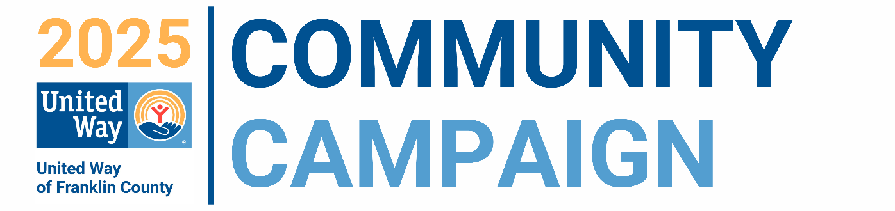
Dear [FIRST NAME],
As our United Way Campaign comes to a close, I am sending one last message to encourage you to get involved If you’ve already given—THANK YOU! You’re helping families right here in Franklin County find stability, support, and hope.
If you are still thinking about it – please keep this in mind: United Way receives much of its funding from workplace campaigns like ours. Every dollar you give truly makes a difference LOCALLY. Each additional person that chooses to contribute to the campaign helps address critical needs in our community.
As a reminder: Anyone who donates $182 or more (that’s just $3.50 a week) to United Way of Franklin County will be entered into the Community Campaign Raffle! Three lucky winners will receive either a $3,500 travel voucher, $1,000 cash, or $500 cash. Please click here for more details about the raffle.
This is your last chance to give and get entered—make your gift today: [INSERT INSTRUCTIONS ON HOW TO GIVE & INCLUDE DEADLINES].
Thanks for everything you do,
[CAMPAIGN COORDINATOR NAME]

